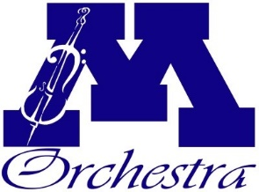
Scholarship Application Form
Minnetonka High School Orchestra

Scholarship Applying For:
Concert Apparel

Student Name :__________________________ Student Email: _____________________________
Guaridan Name: ________________________ Guardian Email: ___________________________

Student’s Orchestra: _____________________
Student Grade: ___________

Scholarship Request:
Please indicate the total amount requested (up to $80) ______________

Return to your orchestra teacher with an attached itemized receipt.

Items eligible for reimbursement/scholarship:
Black dress shoes
Black dress pants/black long skirt/dress shirt/full dress/suit jacket

