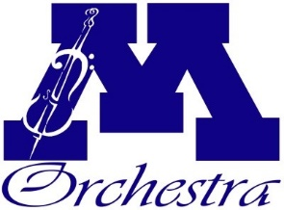
Scholarship Application Form
Minnetonka High School Orchestra

Scholarship Applying For: Travel Study

Student Name :__________________________ Student Email: _____________________________

Parent Name: ___________________________ Parent Email: ______________________________

Student Grade: ___________

How many years has the student participated in MHS Orchestra? ___________

Trip you are applying for:

Please write a brief statement outlining your circumstances and reason for needing travel scholarship funds:

Parent Signature __________________________________ Date ___________________
Students awarded a travel study scholarship will need to participate in at least one group fundraising activity, to ensure sufficient group funds are raised. Please initial here to indicate your understanding of this requirement. ____
Students awarded a travel study scholarship will be required to give 5 volunteer hours to the Orchestra program. Please initial here to indicate your understanding of this requirement. _____
Travel study scholarships are partial scholarships only and awarded based on funds raised by the Boosters Organization.
All information is completely private and confidential. The only person with access to individual student application information is your student’s Orchestra Director.
For administrative use only:
Approval Date ________________
Approval Amount: $_____________
Approval Initials: ______________

